**Monsanto Dicamba Volatility Low-Tunnel 1**

(2018_Mon_Vol_01)

Dr. Rodrigo Werle

Dr. Maxwel Coura Oliveira

Ryan DeWerff

Nikola Arsenijevic

Sarah Striegel

Victor Hugo Vidal Ribeiro

Rachel Renz

August

2018

**Methods**

* *Soybean variety:* NK S25-L9 soybeans
* *Soybean seed rate:* 140,000 seeds acre-1
* *Soybean row width:* 30-inch rows at 1.5 in depth
* *Soybean planting:* 5/24/18
* *PRE-herbicide:* Warrant (48 fl. oz acre-1) + Tricor (0.33 lbs acre-1)
* *PRE-herbicide application:* 5/26/18
* *Herbicide treatments application (Flat):* 06/28/18 (9:11 to 10:20)
* *Soybean stage at flat application:* V4
* *Soybean height at flat application:* 17 cm
* *Flat removal from low-tunnel:* 06/30/18 (10:15 to 11:30)
* Results presented at 14 and 28 DAT (days after treatment)
* Photos taken at 28 DAT





**XtendiMax w/Vaporgrip**

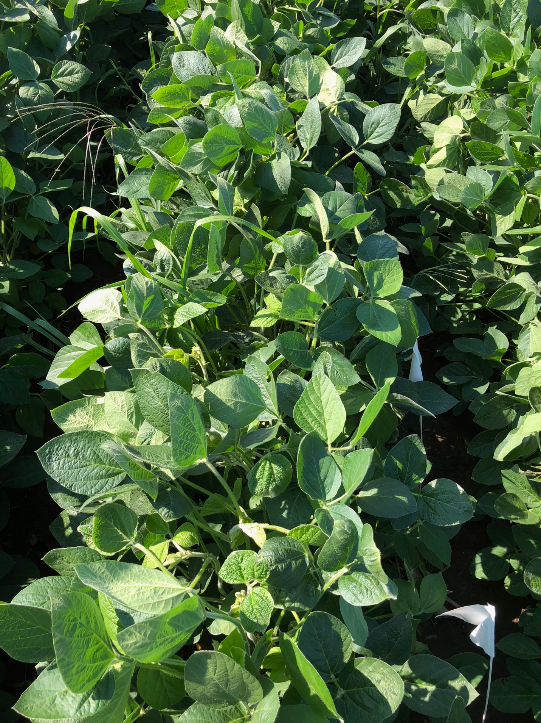

University of Wisconsin-Madison Weed Science

**XtendiMax w/Vaporgrip + Durango DMA**

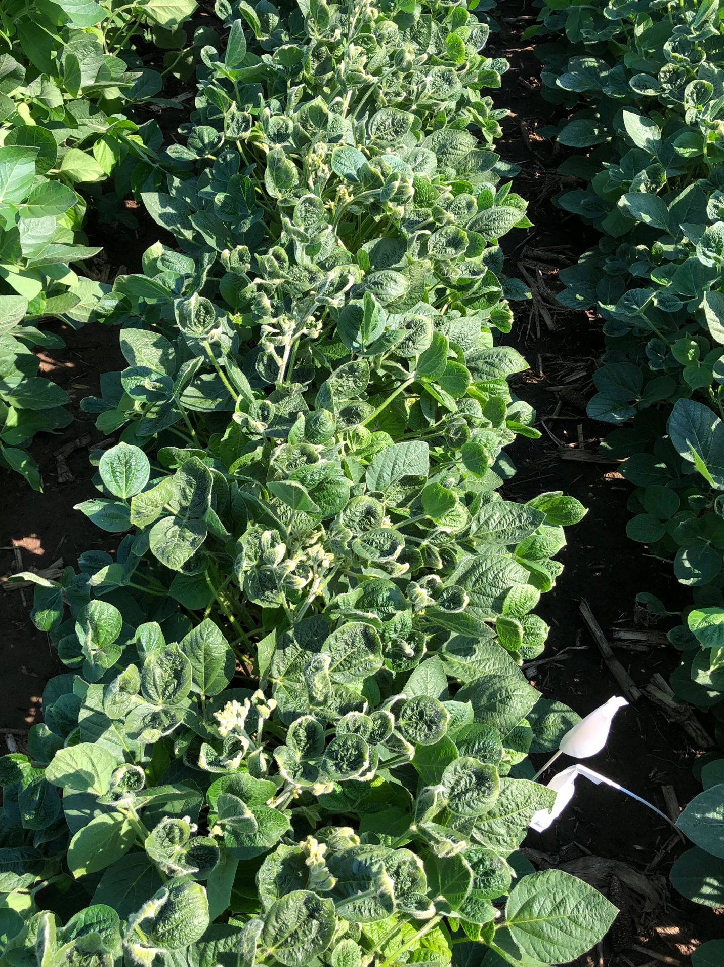

University of Wisconsin-Madison Weed Science

**XtendiMax w/Vaporgrip + PowerMax**

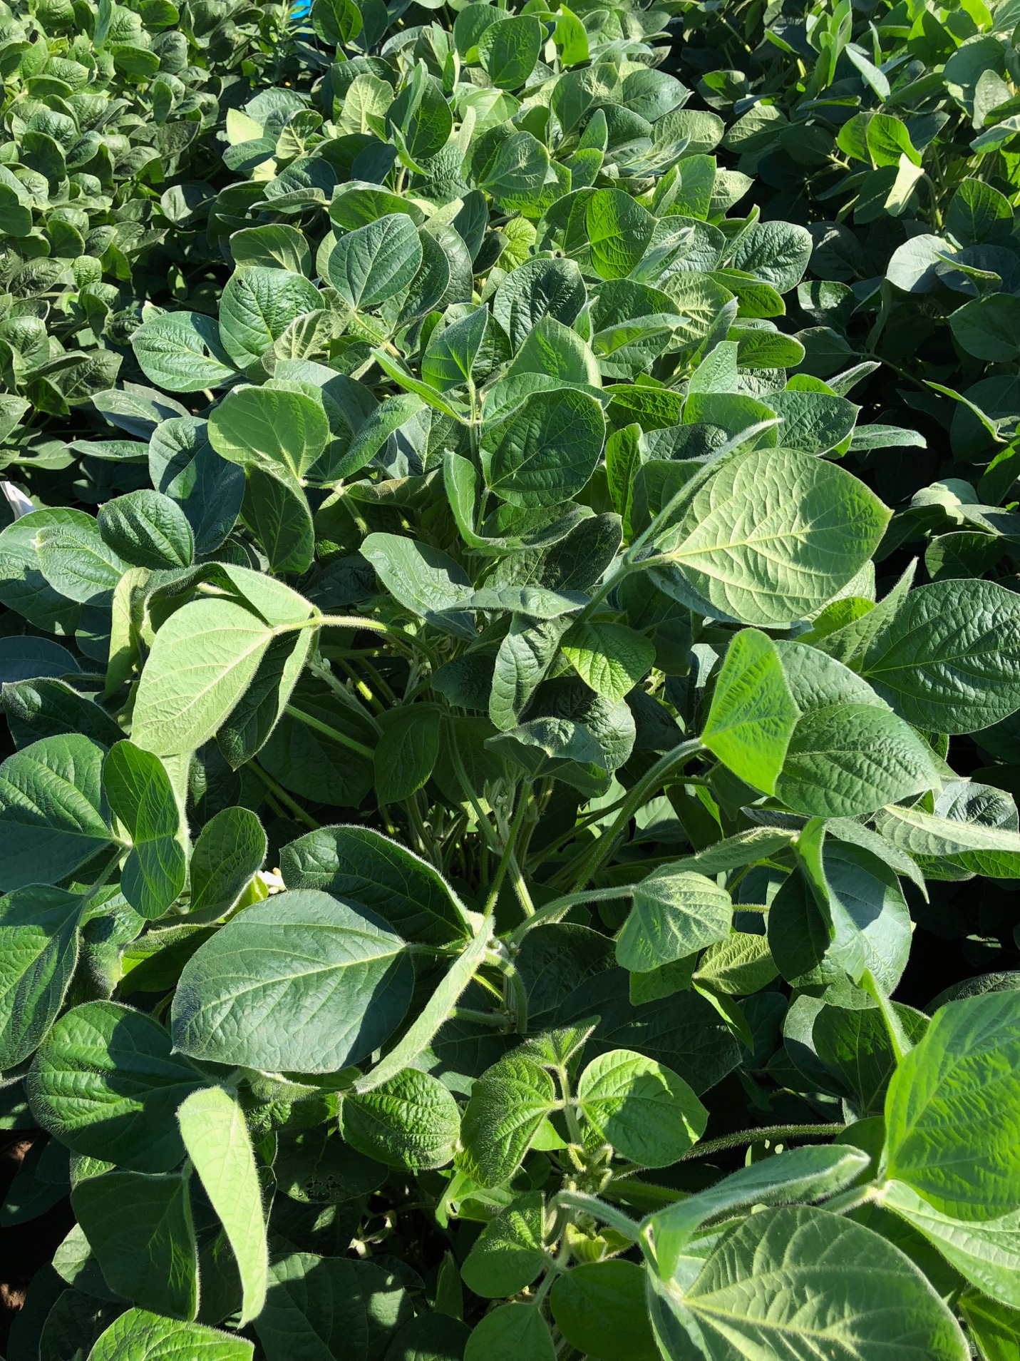

University of Wisconsin-Madison Weed Science

**XtendiMax w/Vaporgrip + PowerMax + Intact**

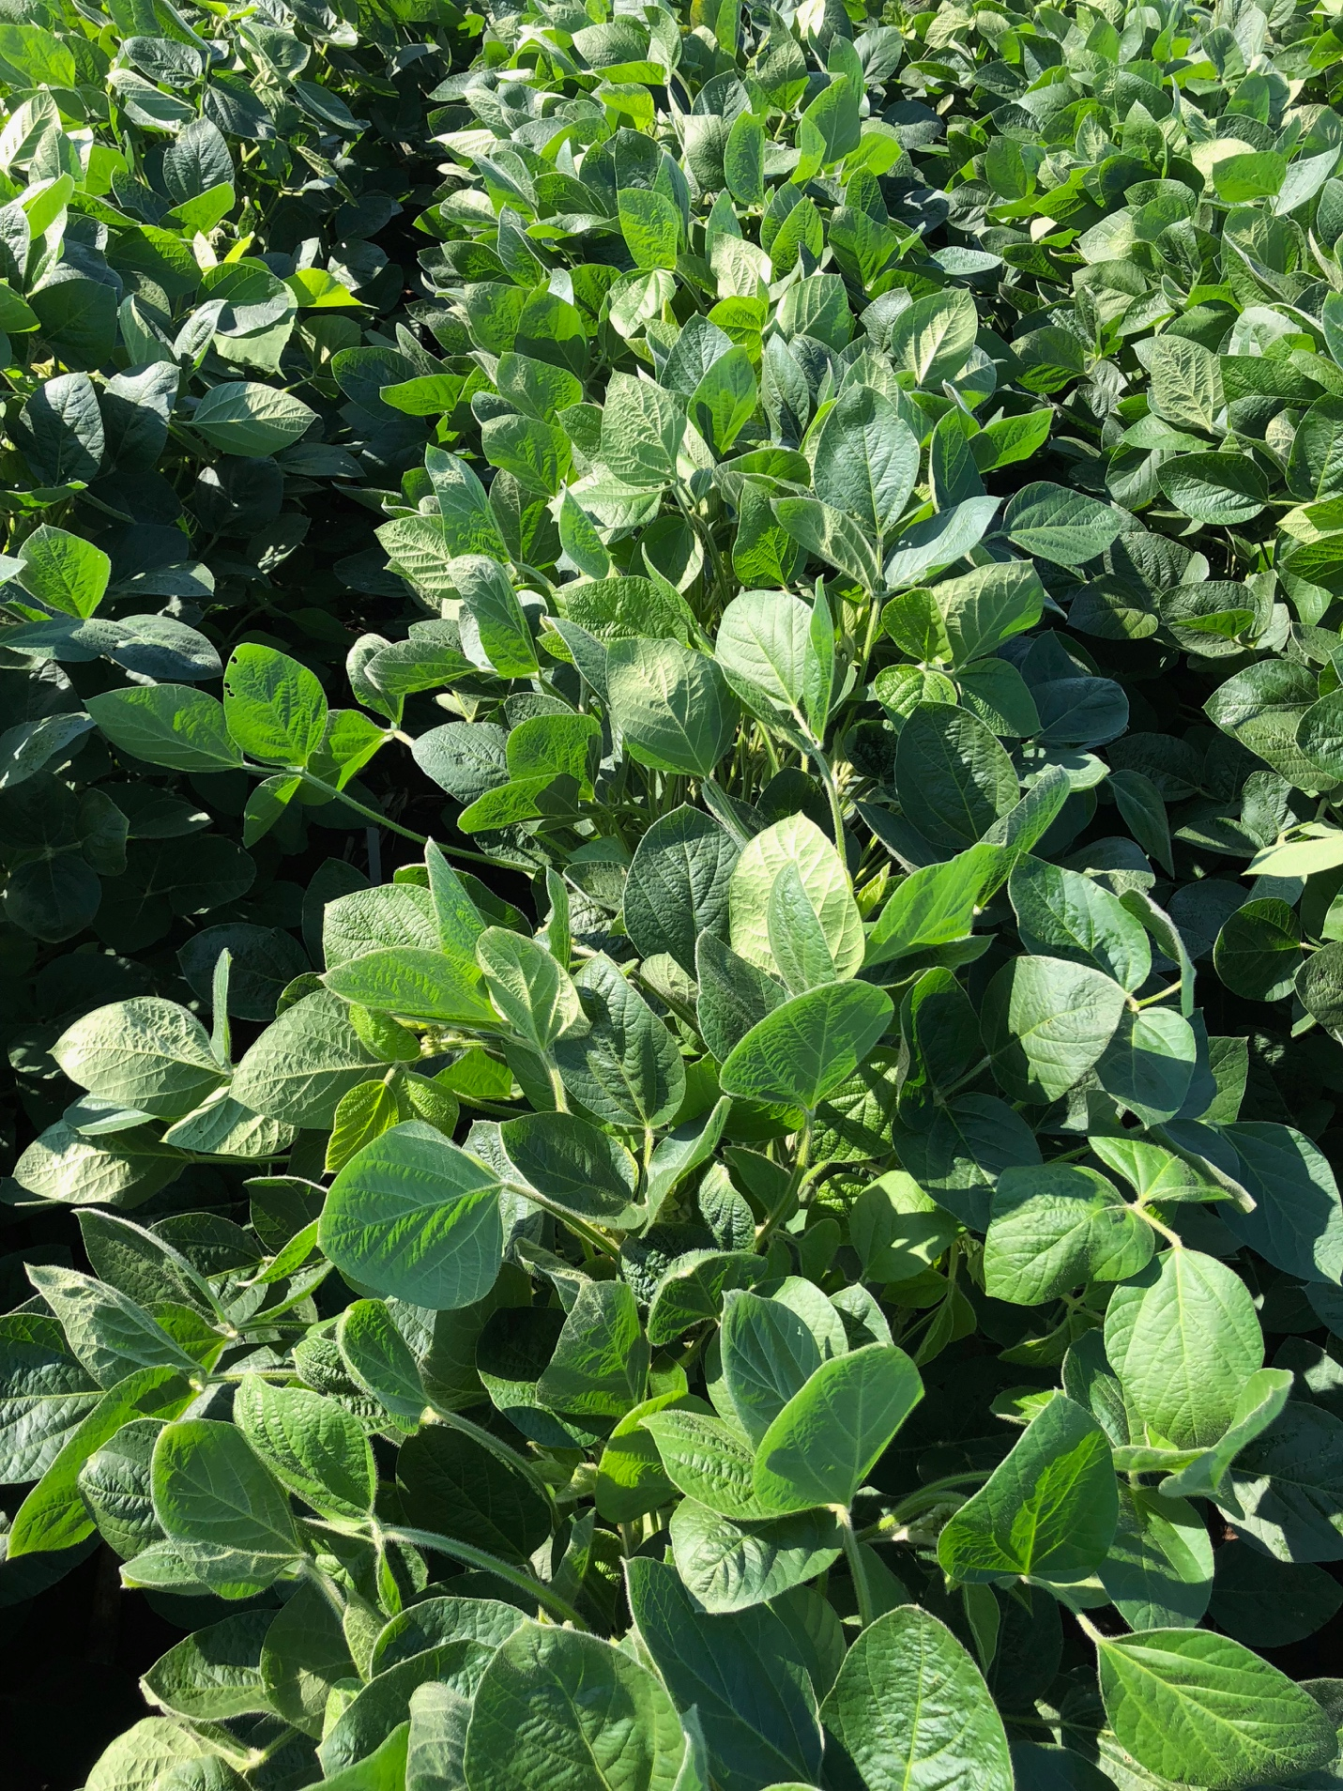

University of Wisconsin-Madison Weed Science

**XtendiMax w/Vaporgrip + PowerMax + Intact + Mon-10**

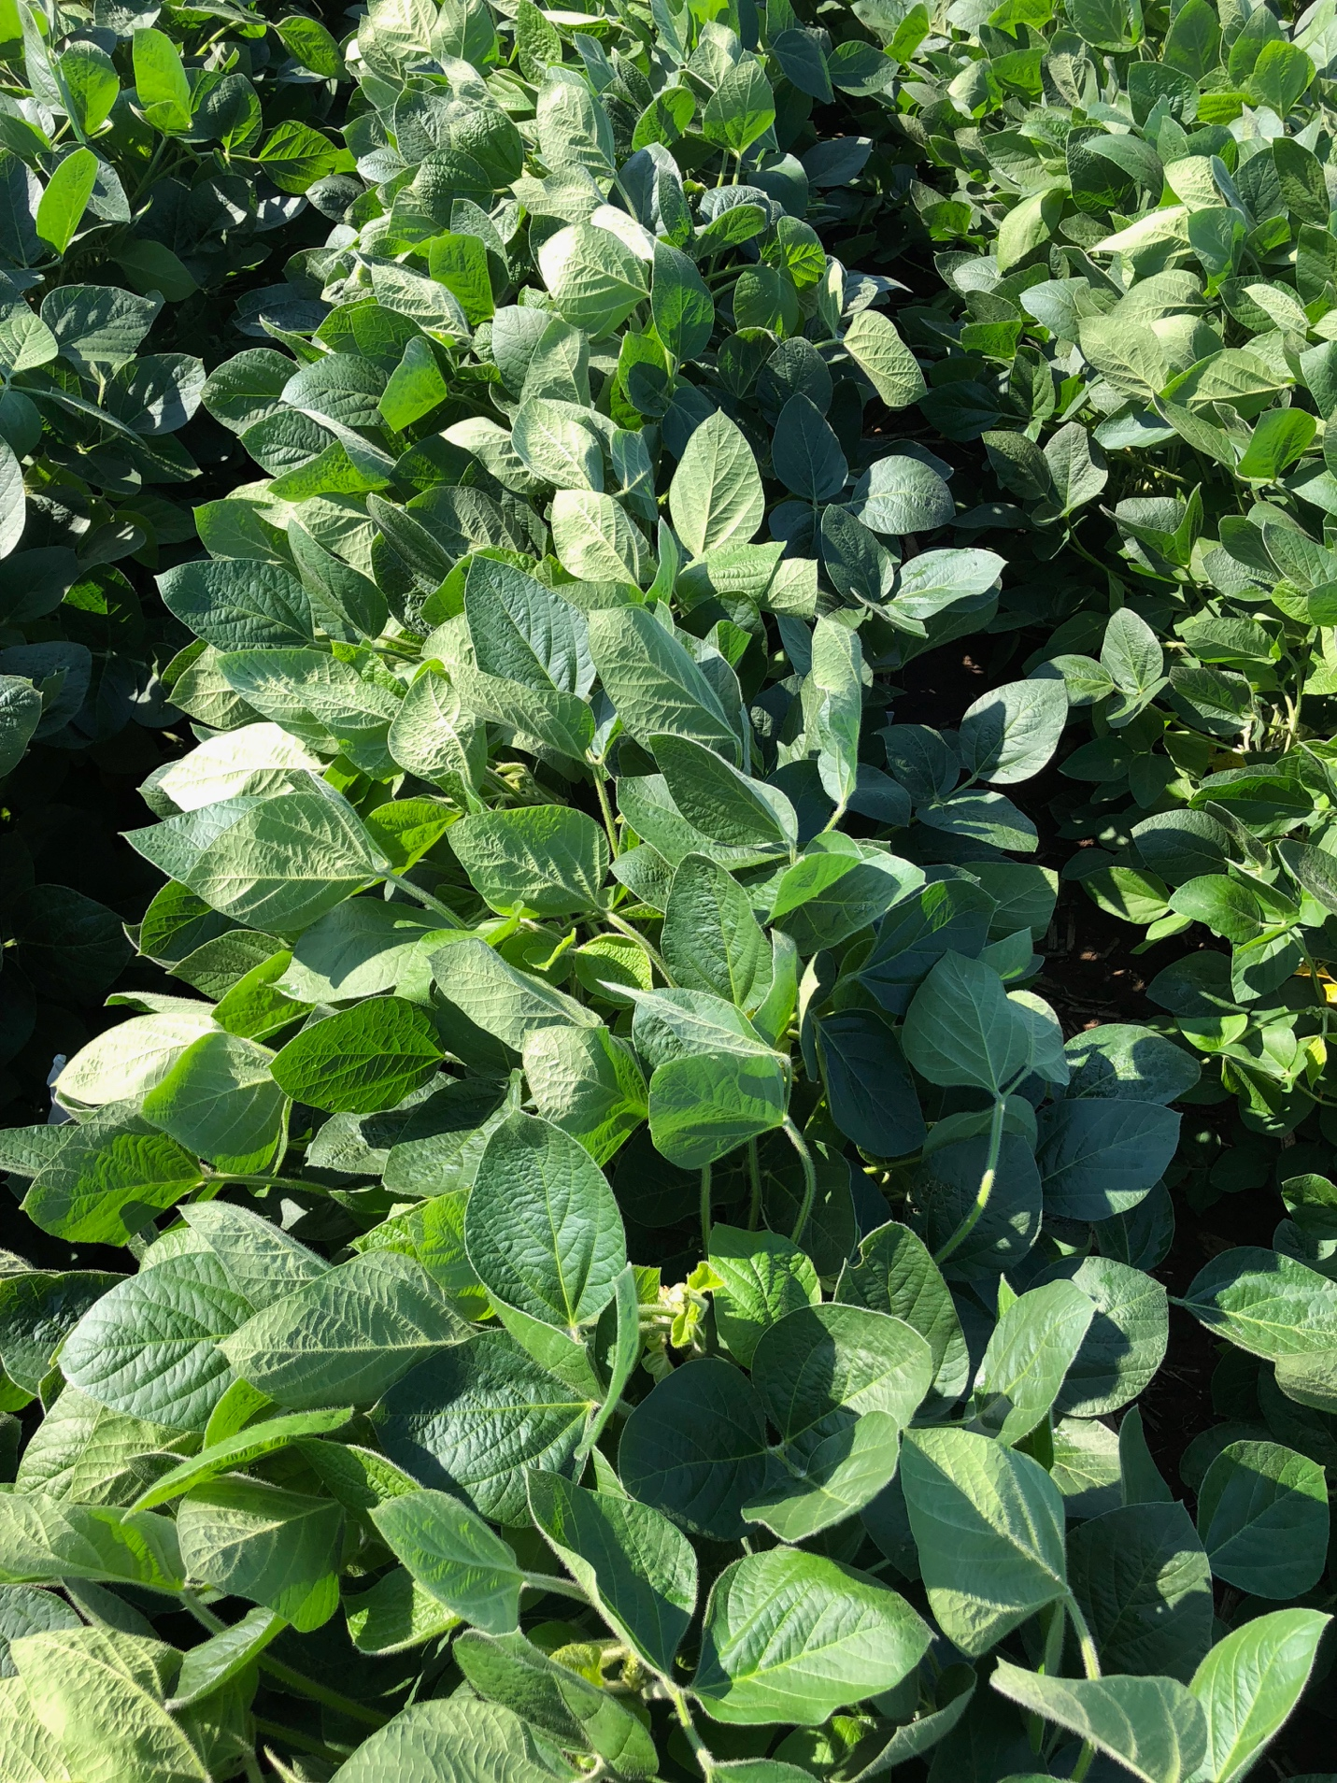

University of Wisconsin-Madison Weed Science

**Mon 76981 – RupXtend**

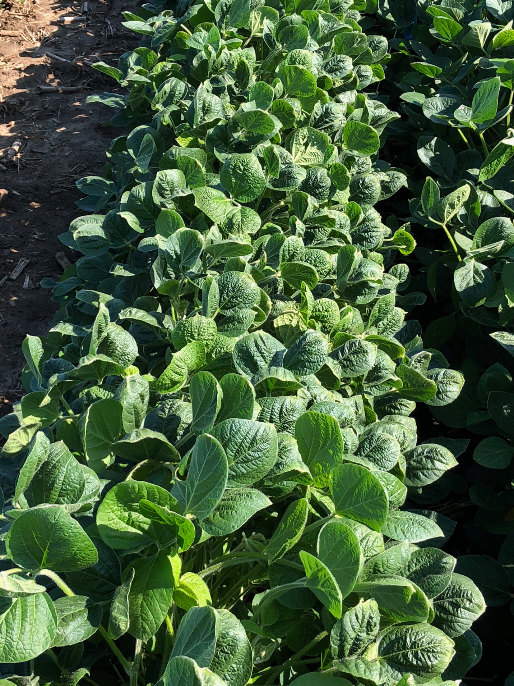

University of Wisconsin-Madison Weed Science

**Mon 76981 – RupXtend + Liberty**

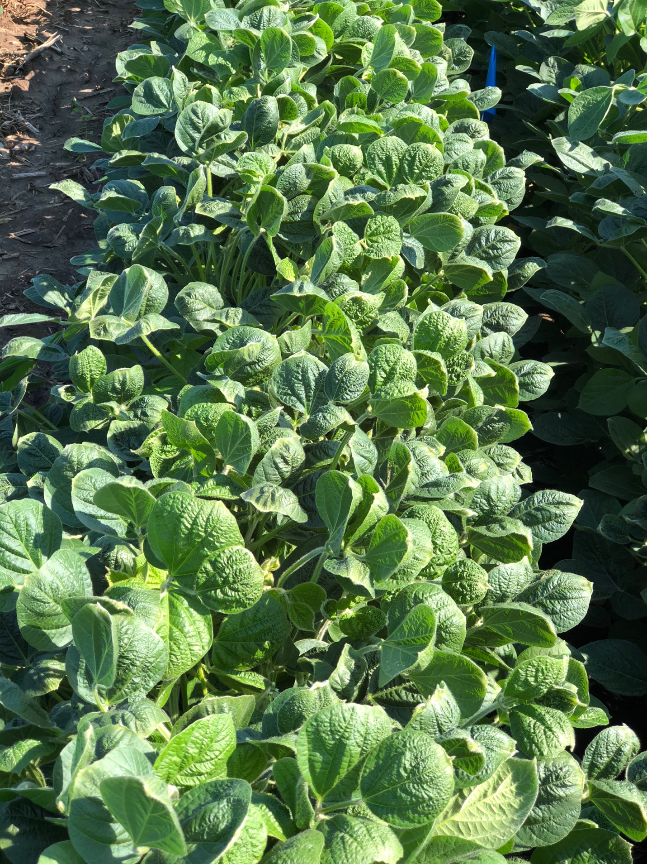

University of Wisconsin-Madison Weed Science

**Untreated**

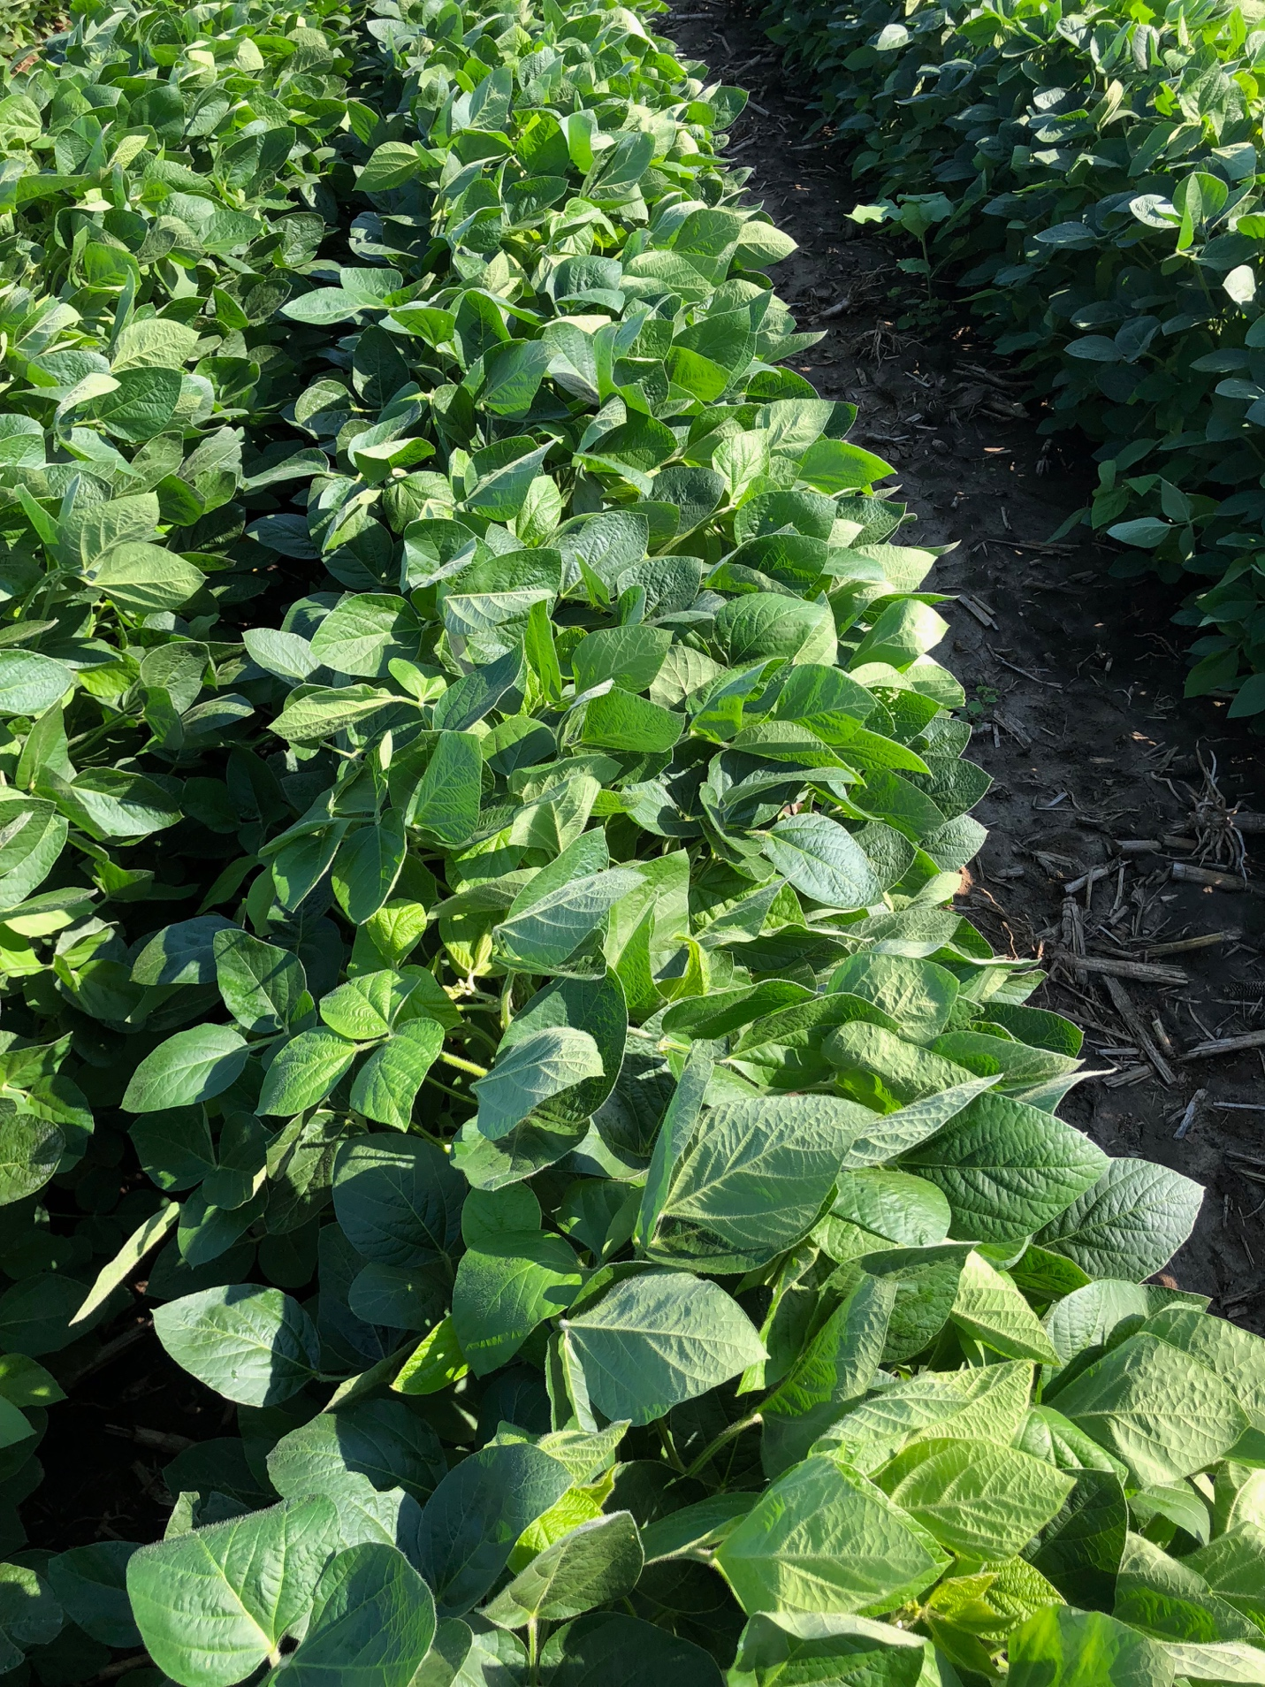

University of Wisconsin-Madison Weed Science